**Course: Advance Bio Informatics**

**Module Title: Building Ontology**

**Module No: 74**

**Building Ontologies**

Methodology would include:

* set of stages
* guidelines and principles
* ontology life-cycle

**Ontology Building Stages**

Ontology building has two stages that are following

**Informal stage:** Natural languagedescriptionsDiagram technique.

**Formal stage:** Formal knowledgerepresentation language,Machine computable.

**Provisional Methodology**

* Skeletal methodology
* SE V-process model

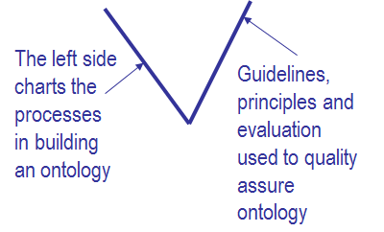

**Ontology Building**

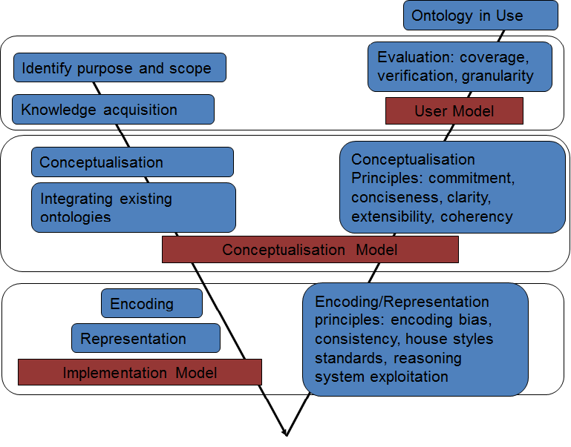

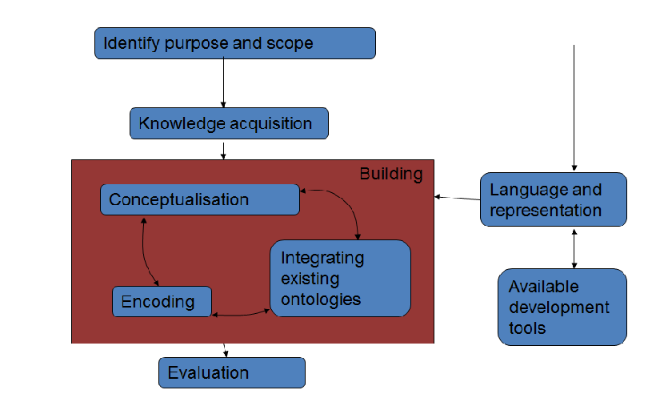

|  |  |  |  |  |
| --- | --- | --- | --- | --- |
| **Chemicals:** | **Molecular-compound** | **Ionic-macromolecular-compound and** | **Protein** | **Nucleic acid –** |
| Atom | Ionic-compound | ionic-small-macromolecular-compound; | peptide | DNA |
| Ion | Ionic-molecular-compound |  | polyprotein | RNA |
| Molecule |  |  | enzyme | tRNA |
| Compound |  |  | holoprotein | mRna |
| Element |  |  | apoprotein | snRNA |

**Conceptualisation Sketch**

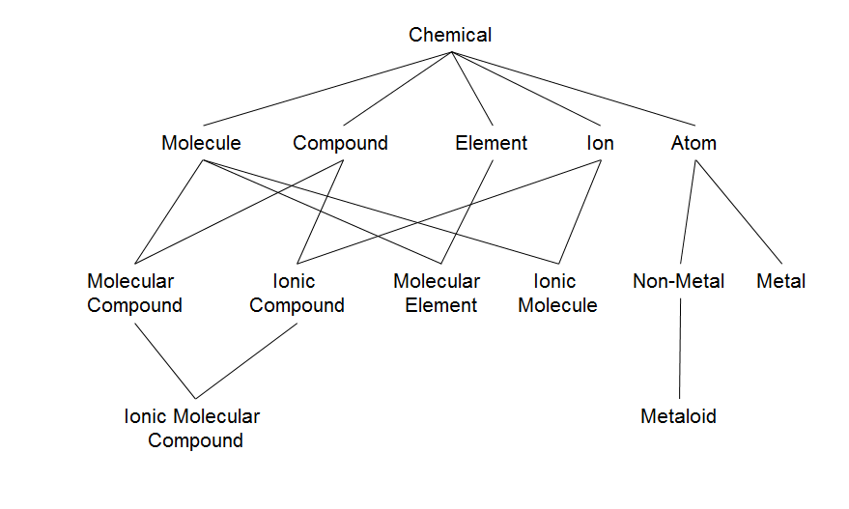

**Molecule Conceptualization Sketch**

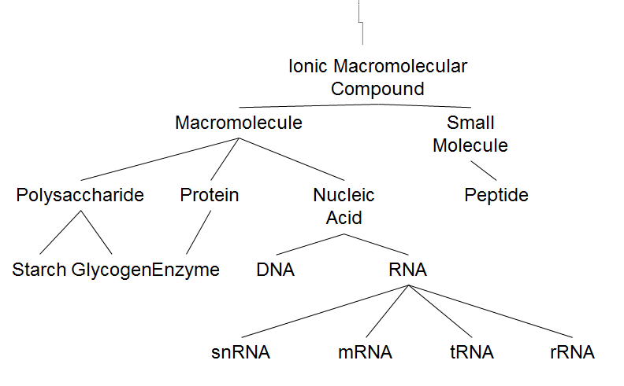

**Expansion**

Sketch & encode in cycles

Build a taxonomy of a small portion

Then build links to other portions

Add more detail

Document source, author, date & argumentation.